**Description**

**Project introduction:**

Epilepsy is one of the most common chronic brain diseases worldwide, which can increase the risk of premature death threefold. There are about 50million epileptic patients worldwide. Among the current treatments, ketogenic diet therapy is more effective for a long time. Long term ketogenic diet may bring side effects such as increased risk of cardiovascular and cerebrovascular diseases and growth retardation in children.

Therefore, we modified the engineered bacteria and encapsulated them in hydrogel, colonized them in the intestine, and produced ketone body β - hydroxybutyric acid (BHb) to replace the efficacy of ketogenic diet, reducing the patients' dependence on ketogenic diet and avoiding the side effects. We also built a prediction model for epilepsy disease monitoring and a sensor for real-time monitoring of EEG in patients with epilepsy, providing more powerful support for the diagnosis and prevention of patients.

This project aims to realize the diagnosis, treatment and multilevel prevention of epilepsy through innovative methods, care about the physical and mental health and quality of life of epilepsy patients, and care for vulnerable groups of epilepsy.

**Why choose epilepsy and introduction to epilepsy**

As the frontier of biology, synthetic biology plays an important role in the treatment of diseases. In the choice of exploration direction, our team wants to use synthetic biology knowledge to help vulnerable groups. We are concerned that, unlike the composition of other diseases, epilepsy patients are mostly low-income people and children. Because epilepsy is difficult to be cured, their daily life is greatly affected and their quality of life is greatly reduced. Therefore, our team focuses on the treatment of epilepsy, hoping to use cutting-edge synthetic biology knowledge to effectively improve their quality of life.

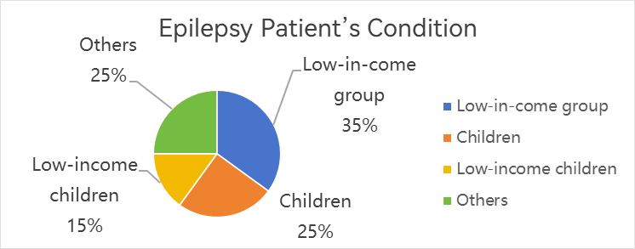

Epilepsy is a chronic brain disease characterized by recurrent seizures, which is one of the most common neurological diseases worldwide. According to the statistics of the World Health Organization (who) in 2024, there are about 50million epileptic patients worldwide, and it is estimated that 5million people worldwide are diagnosed with epilepsy every year. At a given time, 4 to 10 per 1000 people need to be treated. Compared with the general population, epilepsy can increase the risk of premature death threefold. In many parts of the world, patients with epilepsy and their families are humiliated and discriminated against, which has brought them negative psychological and social effects, including anxiety, depression, inferiority complex, learning disabilities, unemployment and a low marriage rate. Because of its extensive impact and serious impact on patients' lives, our team is committed to providing safer and more efficient treatment methods by using synthetic biology related knowledge. We are eager to bring hope to patients suffering from epilepsy.

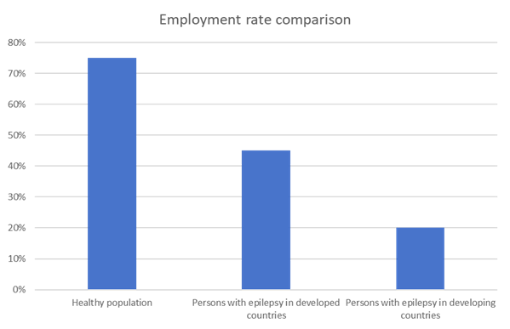

The main etiologies of epilepsy include structural abnormalities (such as brain injury, tumor, stroke, cortical dysplasia), genetic factors (gene mutations affect ion channels or neurotransmitters), infections (encephalitis, meningitis), metabolic disorders (hypoglycemia, electrolyte imbalance), immune abnormalities (autoimmune encephalitis) and unknown causes.

The core of epilepsy pathogenesis is abnormal excessive discharge of neurons, whichmay lead to abnormal electrical activity of local or whole brain synchronization and trigger seizures due to excessive excitatory transmitters (such as glutamate), insufficient inhibitory transmitters (such as GABA), ion channel dysfunction (such as sodium, potassium, calcium channel abnormalities) or synaptic connectivity disorders.

At present, the treatment of epilepsy includes surgical resection, drug treatment, nerve regulation and ketogenic diet. However, these treatments still have some limitations.

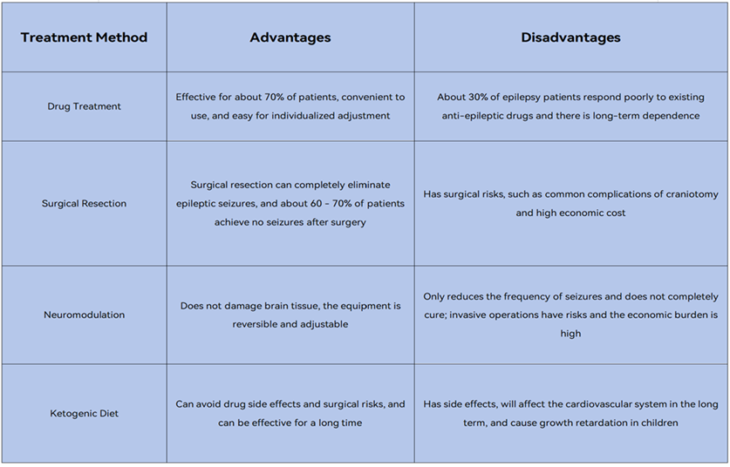

**Why choose ketogenic diet as research direction**

After establishing the treatment of epilepsy as the goal, we formulated several general directions in terms of specific details: through neurotransmitters and receptors, crisper gene editing technology, the study of the termination mechanism of epilepsy, and the improvement method through ketogenic diet. In the following literature survey, we found that: in terms of neurotransmitters, although affecting the combination of neurotransmitters and receptors can treat epilepsy, it will have an impact on the nervous system and cause other neurological diseases for a long time; Crisper gene editing technology is costly and irreversible. Once the operation is wrong, it will cause permanent damage to patients; As for the termination mechanism of epilepsy, once the seizure starts in clinic, the intervention window is very short in seconds, and the individual differences are large, so it is impossible to achieve timely and effective termination.

Among the numerous treatment methods of epilepsy, we have focused on ketogenic diet. Ketogenic diet forces the liver to decompose fat to produce ketone bodies (such as β - hydroxybutyric acid and acetoacetic acid) through the diet mode of extremely low-carbon water and high fat, replacing glucose as the main energy source of the brain. Ketone bodies and their metabolites can regulate the balance of neurotransmitters, inhibit the release of excitatory glutamate, and enhance the role of inhibitory GABA, thereby reducing abnormal neuronal firing. In addition, ketone bodies can optimize mitochondrial function, provide a more stable energy supply, and reduce oxidative stress, further stabilizing the brain cell membrane potential. These mechanisms work together to reduce the frequency of seizures, especially in patients with refractory epilepsy.

Ketogenic diet can break through drug resistance and has a good therapeutic effect on drug-resistant epilepsy; Multiple pathways and mechanisms work together and are effective for a variety of epilepsies; Ketone bodies are produced by themselves and act on the nervous system, which can reduce the damage to the nervous system for a long time. At the same time, the treatment of ketogenic diet is more daily, more acceptable to the public, and can avoid drug side effects, dependence and surgical risks, which greatly guarantees the quality of life of patients and can be effective for a long time. It is currently the preferred method for the treatment of refractory epilepsy.

However, the traditional ketogenic diet in the treatment of epilepsy may cause a variety of side effects, and the mechanism is different. Short term common side effects include gastrointestinal discomfort (such as nausea and constipation), which is mainly caused by high-fat diet delaying gastric emptying and changing intestinal flora; Hypoglycemia and fatigue are caused by poor adaptation of energy metabolism during the transition period caused by sudden reduction of carbohydrates. Electrolyte disturbance (low sodium, low magnesium, etc.) is due to the increase of renal sodium excretion due to the decrease of insulin level, and the diuretic effect of ketone bodies accelerates mineral excretion. Long term possible kidney stones are associated with hyperuricemia (ketone bodies compete for tubular excretion) and increased urinary calcium (metabolic acidosis promotes bone calcium dissolution). Dyslipidemia (high cholesterol and triglycerides) is mainly due to the continuous high-fat intake exceeding metabolic capacity, especially in individuals with specific genotypes. Growth retardation may occur in children, which is associated with inadequate caloric / protein intake and reduced insulin-like growth factor levels. The most serious ketoacidosis occurs rarely, and is mostly seen in patients with absolute insulin deficiency. The blood pH value decreases due to excessive accumulation of ketone bodies. The therapeutic effect of ketogenic diet is highly dependent on patients' strict adherence to the dietary plan. Patients are too young to adapt to dietary adjustment and have a low degree of cooperation; The initial cost of ketogenic diet is high, and it is difficult for ordinary families to adhere to it, which will lead to poor treatment effect. In addition, the taste of ketogenic diet is poor, and the happiness index of patients is reduced. In the long run, it has a great impact on the psychology of patients.

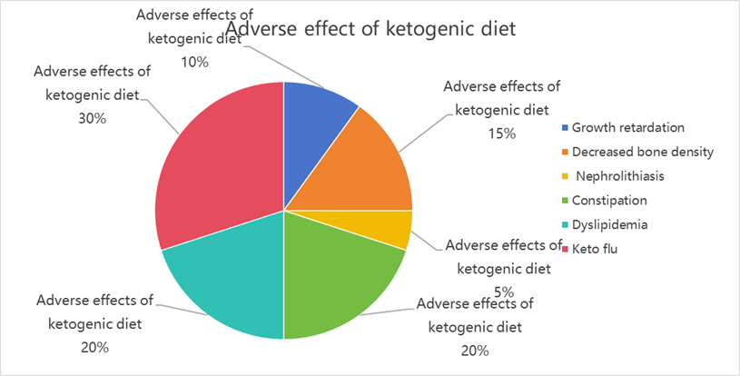

**Our ideas**

So we envision: using synthetic biology methods to transform E. coli, design pathways to enable the engineered bacteria to produce ketone body β - hydroxybutyric acid (BHB), wrap the engineered bacteria in hydrogel, colonize it in the gut, and produce β - hydroxybutyric acid (BHB) that can reach the concentration level of epilepsy treatment, so as to achieve the same therapeutic effect of ketogenic diet. This way can not only bypass the pathway of liver ketogenesis and avoid the adverse reactions, but also reduce the patients' dependence on strict low-carbon and high-fat diet.

We have groundbreaking transformed the human safety grade probiotic Escherichia coli nissle 1917 to directly synthesize antiepileptic molecule BHB in the gut, bypassing the metabolic burden of the liver. Through two innovative designs:

1、Hydrogel colonization Technology: enhancing intestinal resident ability.

2、Quorum sensing system: real time regulation of bacterial density and blocking gene diffusion.

To achieve precise, safe and oral alternative therapy, so that patients can get rid of strict dietary restrictions and lifelong drug dependence.

**Wet lab**

Epilepsy affects 70 million people globally, with 80% residing in medically underserved regions. In China alone, nearly 10 million patients struggle with lifelong medication, social stigma, and 3 - 10× higher mortality. Current treatments face critical limitations: drug toxicity, surgical risks, ethical barriers in stem-cell therapy, and keto diet complications.

We engineered a breakthrough solution using human-safe probiotic E. coli Nissle 1917:

Direct BHB synthesis in the gut–bypassing liver metabolism

Dual-control innovation:

Hydrogel encapsulation for enhanced colonization

Smart quorum sensing system regulating bacterial density and blocking gene transfer

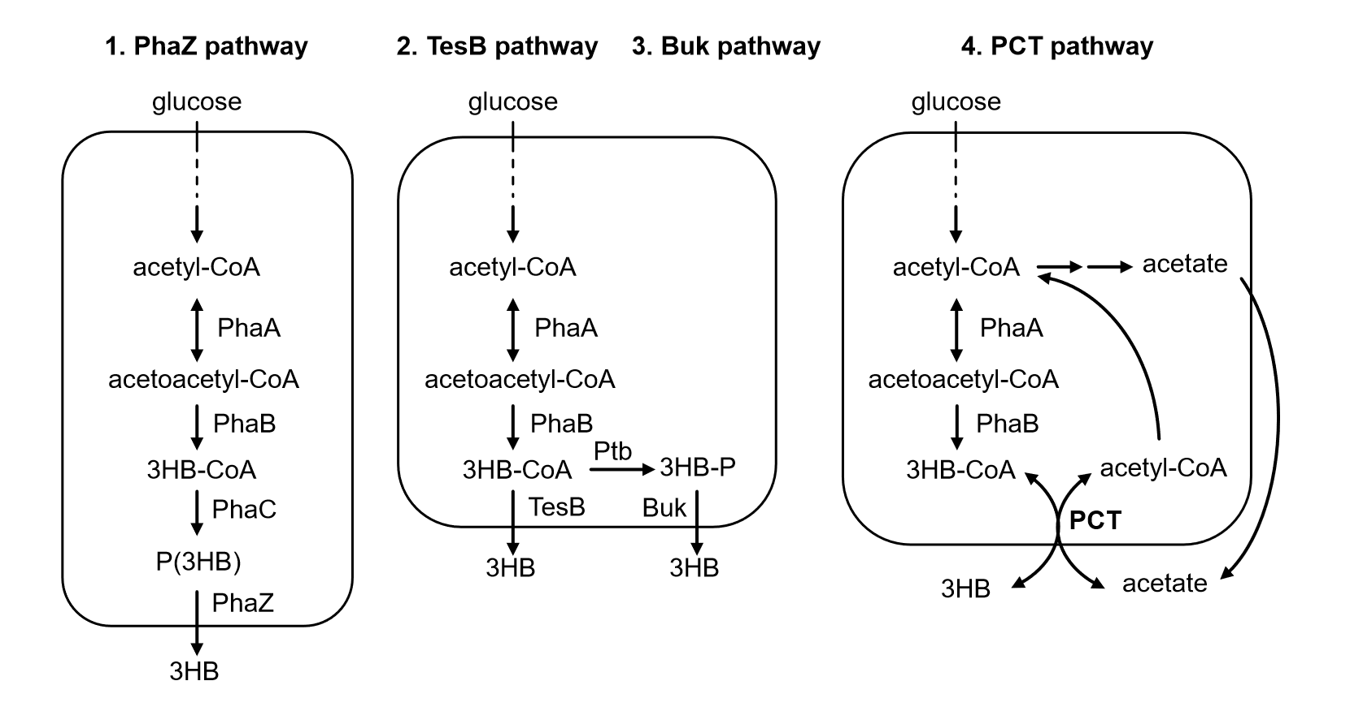

The working principle of the quorum sensing system is generally as follows. First, bacteria synthesize and release signal molecules through their own enzyme genes. As cell density increases, the concentration of signal molecules also increases. When the concentration reaches a certain threshold, the signal molecules bind with corresponding receptor proteins to form complexes, triggering a signal transduction cascade reaction. This alters the expression of specific genes, ultimately changing the specific behavior of bacteria. Conceptual design of a quorum sensing system: To effectively redirect carbon flux from glycolysis to gluconate production, a pathway-independent quorum sensing (QS) switch was designed to autonomously regulate the expression of Pfk-1. The QS gene circuit primarily regulates gene expression through the self-inducing molecule 3-oxohexanoylhomoserine lactone (AHL) in a cell density-dependent manner. In the absence of AHL, the transcription regulator Esa RI70V (a mutant of the original EsaR) binds to the homologous promoter Pesa S, activating transcription. The accumulation of AHL disrupts the binding of Esa RI70V to DNA, thereby reducing gene transcription at the Pesa S promoter. One challenge is to determine the appropriate timing for activating the Pesa S promoter to effectively switch carbon flux from glycolysis to gluconate production. Since AHL is produced by the AHL synthase Esa I, the switching time of the Pesa S promoter can be controlled and regulated by modulating the expression of Esa I, which can be achieved using a library of promoter and ribosome binding site mutants.

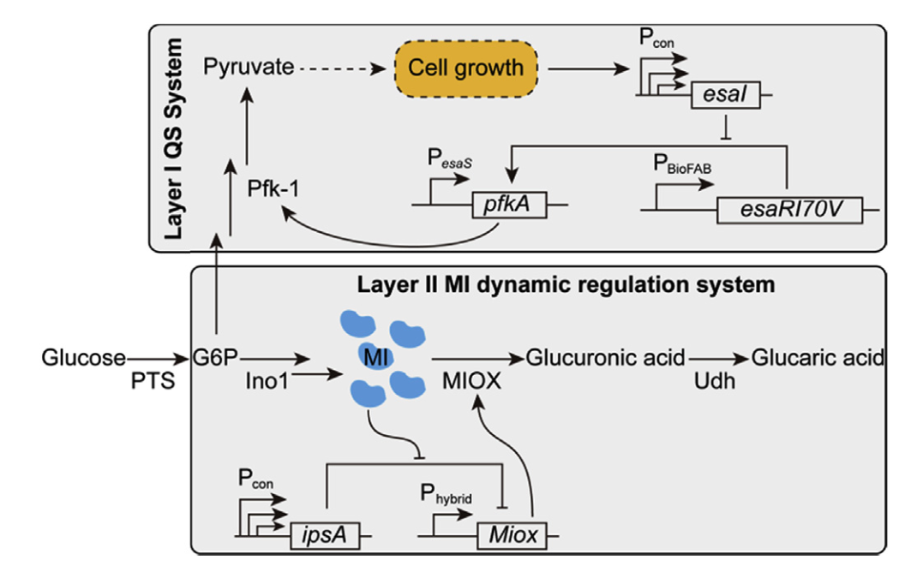

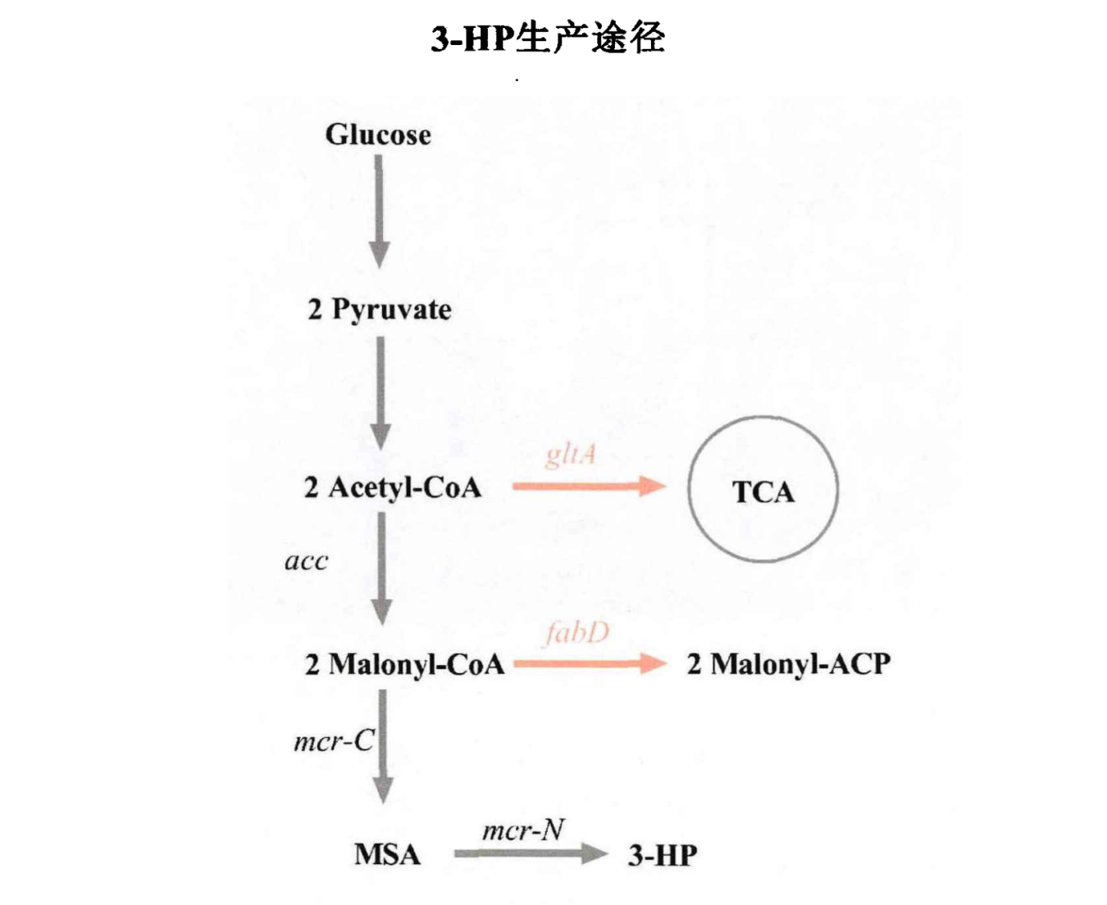

In metabolic engineering, increasing the accumulation of intermediates can effectively enhance yield. In the 3-HP production pathway, the two intermediate products acetyl-CoA and malonyl-CoA flow not only toward 3-HP but also toward other pathways. Acetyl-CoA flows into the TCA cycle, and the enzyme catalyzing this reaction is citrate synthase, encoded by g/A: Malonyl-CoA flows into the fatty acid cycle, where the enzyme catalyzing this reaction is malonyl-CoA transketolase, encoded by fabD. Studies have shown that gltA and fabD are essential genes for bacterial growth, and their knockout leads to cell death. We combined the quorum sensing system with artificially reverse-encoded small RNAs to dynamically inhibit the expression of gltA or fabD, thereby reducing their impact on cells. In this step, we constructed two dual-layer regulated production strains, Strain1 and Strain2. In Strain1, we combined the Tra system with the artificial trans-encoded small RNA (MicC1) system to dynamically inhibit fabD, accumulate malonyl-CoA, and induce the expression of acc and mcr genes using the P31 promoter. At the beginning of fermentation, the bacterial population is low, and the amount of AHL produced is insufficient to activate the quorum sensing system. When the bacterial population reaches a certain OD600, the quorum sensing system promoter begins to express MicC1 to inhibit fabD, thereby reducing the flow of malonyl coenzyme A into the fatty acid cycle and redirecting it to the 3-HP production pathway. In Strain 2, we combined the Las system with an artificially trans-encoded small RNA (MicC2) system to dynamically inhibit gltA, accumulate acetyl-CoA, and induce the expression of the acc and mcr genes using the P3.1 promoter. At the onset of fermentation, the cell population is low, and the amount of AHL produced is insufficient to activate the quorum sensing system. When the cell density reaches a certain OD600 value, the quorum sensing system promoter begins to express and induce MicC1 to inhibit gltA, thereby reducing the flow of acetyl-CoA into the TCA cycle and redirecting it toward the 3-HP production pathway. In practice, we prefer to choose a simpler pathway.

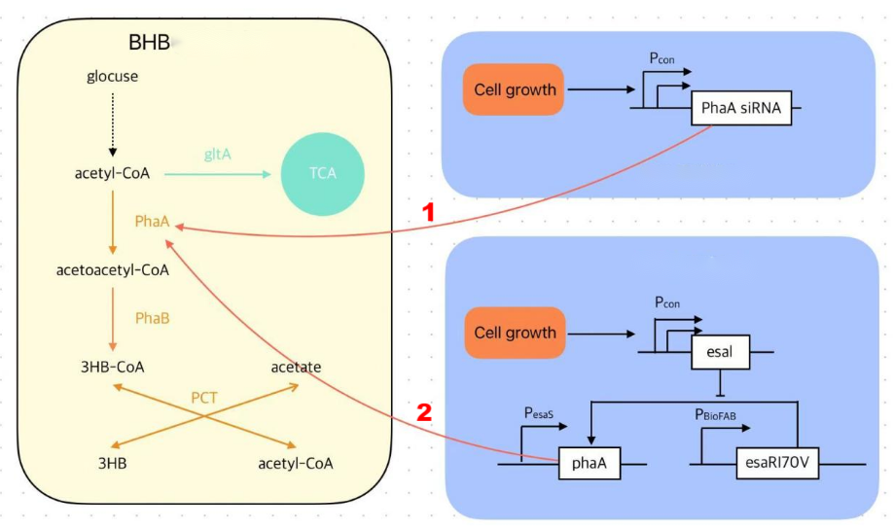

Delivering a precise, oral therapy that liberates patients from strict diets and lifelong drugs.

Why It Matters?

Affordable solution for low-resource communities. World's first quorum-sensing application in epilepsy treatment. Redefining neurocare accessibility through synthetic biology.

**Model**

Epileptic seizures are accompanied by characteristic spike waves, sharp waves, and spike-and-slow complex waves. Detecting and extracting these waveforms is of paramount importance for preventingand promptly managing early epileptic seizures.

To detect and predict epilepsy, we designed to develop an EEG-based model for detecting and predicting epilepsy. After extracting and analyzing the time-frequency features of raw electroencephalogram (EEG) signals, we employed three different types of machine learning models—supervised learning, unsupervised learning, and ensemble learning—for detection and prediction. The aim is to accurately identify potential seizure risks and provide an assessment.

**Hardware**

In terms of hardware, we mainly focus on two aspects of work:

1. The human brain is divided into many different regions, and these regions exhibit distinct EEG characteristics during epileptic seizures. Considering the necessity of EEG extraction and the potential social embarrassment for patients wearing head-mounted EEG extraction devices, we have overcome the drawbacks of such devices and developed a compact peri-auricular EEG extraction device called cEEGrid. This device features an 8-channel flexible electrode array behind the ear. After extracting the EEG, the signal is amplified and transmitted to our developed software via Bluetooth for subsequent processing.

2. The colonization of engineered bacteria and the frequent exchange of genetic material at the level of the intestinal microbiota pose challenges in wet experiments. Hydrogel materials have excellent encapsulation properties. By using acid-resistant and enzyme-resistant materials and designing the hydrogel to adhere to specific intestinal mucosa, the colonization efficiency of engineered bacteria can be enhanced, and the contact with the intestinal microbiota can be reduced to lower the probability of genetic material exchange within the microbiota.

**Software**

After obtaining the EEG, we are actually more concerned about how these signals can provide us with assistance and guidance. After completing the construction of the EEG-based model for detecting and predicting epilepsy, we took it as the core and developed the corresponding epilepsy disease prediction software. The software receives the raw EEG transmitted by cEEGrid via Bluetooth, processes it, and then passes this part of the signal to the model. Finally, it visualizes the risk of epilepsy onset, assisting patients and doctors in making preliminary judgments and better completing the prevention and treatment of epilepsy.

**Reference**

1. Wu, X. T., Zhao, C. Y., & Zhou, D. (2025). Standard operating procedure for vagus nerve stimulation in the treatment of epilepsy (draft). Journal of Epilepsy, 1-5. Retrieved February 28, 2025, from <http://kns.cnki.net/kcms/detail/51.1762.R.20250225.1835.002.html>  
   [2] Fan, X. L., Bai, Y. T., Yang, A. C., et al. (2025). Advances in responsive neurostimulation therapy for refractory epilepsy. Chinese Journal of Modern Nervous Diseases, 25(1), 11-16.  
   [3] Wu, Y., Zhang, K., Liu, Q. Z., et al. (2025). Chinese expert consensus on vagus nerve stimulation for pediatric drug-resistant epilepsy. Journal of Epilepsy, 11(1), 1-11.  
   [4] Lian, Y. Q., & Zhao, Y. H. (2024). Research status of refractory epilepsy. Tibetan Medicine, 45(6), 153-155.

[5] Shu, J. X., & Zhang, A. H. (2024). Advances in the treatment of refractory epilepsy in children. Modern Medicine, 52(2), 296-301.  
[6] Yu, S. T., & Yao, B. Z. (2023). Research progress on refractory epilepsy in children. Journal of Rare Diseases, 22(5), 546-551.  
[7] Zhou, Y., Wu, Q., Yu, C. F., et al. (2022). Current status and influencing factors of medication adherence in children with epilepsy. Journal of Pediatric Pharmacy, 28(7), 21-26. <https://doi.org/10.13407/j.cnki.jpp.1672-108X.2022.07.006>

[8] World Health Organization. (2024, February 7). Epilepsy. Retrieved February 18, 2025,from <https://www.who.int/news-room/fact-sheets/detail/epilepsy>

[9] China Association Against Epilepsy. (n.d.). Popular science on epilepsy. Retrieved February 18, 2025, from <https://caae.org.cn/patientshome/popularscience/gid/6/p/5.html>

[10] Liu, W, Xu, Y, Lin, Y, et, 2023. Burden of epilepsy in China and its provinces, 1990 to 2019:

findings from the Global Burden of Disease Study 2019. Chinese Medical Journal.

[11] WHO. Intersectoral global action plan on epilepsy and other neurological disorders 2022-2031.

July 20, 2023.

[12] Specchio, N, Wirrell, E.C, Scheffer, I.E, et, 2022. International League Against Epilepsy

classification and definition of epilepsy syndromes with onset in childhood: Position paper by the

ILAE Task Force on Nosology and Definitions. Epilepsia 63, 1398–1442.

[13] Scheffer, I.E, Berkovic, S, Capovilla, G,et, 2017. ILAE classification of the epilepsies: Position

paper of the ILAE Commission for Classification and Terminology. Epilepsia 58, 512–521.

[14] Hu, Y, Shan, Y, Du, Q, et., 2021. Gender and Socioeconomic Disparities in Global Burden of

Epilepsy: An Analysis of Time Trends From 1990 to 2017. Front. Neurol. 12, 643450. [6] Liu, W.,

Xu, Y., Lin, Y., Wang, L., Zhou, M., Yin, P., Zhao, G., 2023. Burden of epilepsy in China and its

provinces, 1990 to 2019: findings from the Global Burden of Disease Study 2019. Chinese Medical

Journal.

[15] Feigin, V.L, Vos, T, Nair, B.S,et., 2025. Global, regional, and national burden of epilepsy, 1990–

2021: a systematic analysis for the Global Burden of Disease Study 2021. The Lancet Public Health

10, e203–e227.

[16] O’Donohoe, T.J., Choudhury, A., Callander, E., 2020. Global macroeconomic burden of epilesy and

the role for neurosurgery: a modelling study based upon the 2016 Global Burden of Disease

data. Eur J Neurol 27, 360–368.

[17] Li, S., Wu, J., Wang, W., Jacoby, A., de Boer, H., Sander, J.W., 2010. Stigma and epilepsy: The

Chinese perspective. Epilepsy & Behavior 17, 242–245.

[18] Shen M, Yang F, Wen P, Song B, Li Y. A real-time epilepsy seizure detection approach based on EEG using short-time Fourier transform and Google-Net convolutional neural network. Heliyon. 2024;10(11):e31827. Published 2024 May 23. doi:10.1016/j.heliyon.2024.e31827

[19] Dash, S., Dash, D. K., Tripathy, R. K., & Pachori, R. B. (2025). Time–frequency domain machine learning for detection of epilepsy using wearable EEG sensor signals recorded during physical activities. Biomedical Signal Processing and Control, 100, 107041.

[20] Kim, M., Yoo, S., & Kim, C. (2022). Miniaturization for wearable EEG systems: recording hardware and data processing. Biomedical engineering letters, 12(3), 239–250.

[21] Du, X., Wang, X., Zhu, L., Ding, X., Lv, Y., Qiu, S., & Liu, Q. (2024). Electroencephalographic Signal Data Augmentation Based on Improved Generative Adversarial Network. Brain sciences, 14(4), 367.

[22] Wang, Q., Liu, Q., Zhong, G., Xu, T., & Zhang, X. (2024). Wearable Vertical Graphene-Based Microneedle Biosensor for Real-Time Ketogenic Diet Management. Analytical chemistry, 96(21), 8713–8720.

[23] Abbasi, B., & Goldenholz, D. M. (2019). Machine learning applications in epilepsy. Epilepsia, 60(10), 2037–2047.

[24] Tautan, A. M., Andrei, A. G., Smeralda, C. L., Vatti, G., Rossi, S., & Ionescu, B. (2025). Unsupervised learning from EEG data for epilepsy: A systematic literature review. Artificial intelligence in medicine, 162, 103095.

[25] Kang, L., Chen, J., Huang, J., Zhang, T., & Xu, J. (2022). Identifying epilepsy based on machine-learning technique with diffusion kurtosis tensor. CNS neuroscience & therapeutics, 28(3), 354–363.

[26] Liu, W, Xu, Y, Lin, Y, et, 2023. Burden of epilepsy in China and its provinces, 1990 to 2019: findings from the Global Burden of Disease Study 2019. Chinese Medical Journal.

[27] WHO. Intersectoral global action plan on epilepsy and other neurological disorders 2022–2031. July 20, 2023.

[28] Specchio, N, Wirrell, E.C, Scheffer, I.E, et, 2022. International League Against Epilepsy classification and definition of epilepsy syndromes with onset in childhood: Position paper by the ILAE Task Force on Nosology and Definitions. Epilepsia 63, 1398–1442.

[29] Scheffer, I.E, Berkovic, S, Capovilla, G,et, 2017. ILAE classification of the epilepsies: Position paper of the ILAE Commission for Classification and Terminology. Epilepsia 58, 512–521.

[30] Hu, Y, Shan, Y, Du, Q, et., 2021. Gender and Socioeconomic Disparities in Global Burden of Epilepsy: An Analysis of Time Trends From 1990 to 2017. Front. Neurol. 12, 643450. [6] Liu, W., Xu, Y., Lin, Y., Wang, L., Zhou, M., Yin, P., Zhao, G., 2023. Burden of epilepsy in China and its provinces, 1990 to 2019: findings from the Global Burden of Disease Study 2019. Chinese Medical Journal.

[31] Feigin, V.L, Vos, T, Nair, B.S,et., 2025. Global, regional, and national burden of epilepsy, 1990–2021: a systematic analysis for the Global Burden of Disease Study 2021. The Lancet Public Health 10, e203–e227.

[32] O’Donohoe, T.J., Choudhury, A., Callander, E., 2020. Global macroeconomic burden of epilepsy and the role for neurosurgery: a modelling study based upon the 2016 Global Burden of Disease data. Eur J Neurol 27, 360–368.

[33] Li, S., Wu, J., Wang, W., Jacoby, A., de Boer, H., Sander, J.W., 2010. Stigma and epilepsy: The Chinese perspective. Epilepsy & Behavior 17, 242–245.